PC00002114A – Snir & Yoav
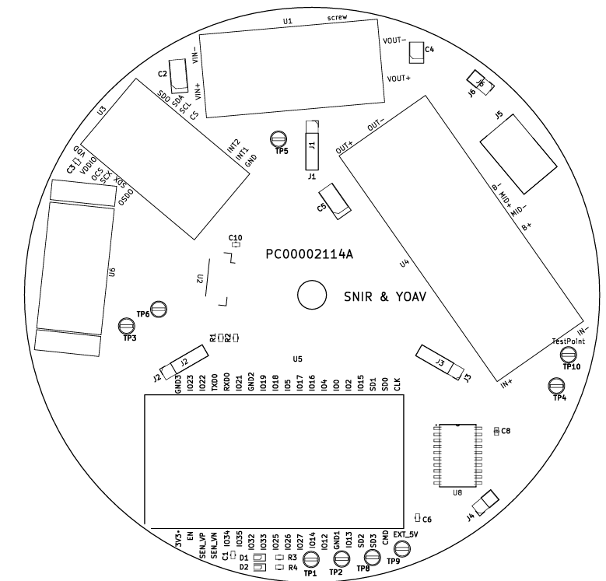
First PCB – front layout

PC00002114A – Snir & Yoav
First PCB – Back Layout
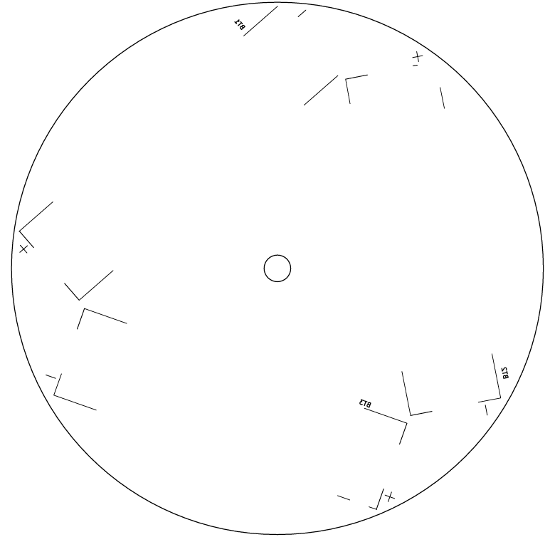

Designator | Footprint | Quantity | Value
BT1, BT2, BT3 | battery_holder | 3 | Battery Holder
C1, C10, C3, C6, C8 | 603 | 5 | 10u
C2, C5 | CP_EIA-6032-28_Kemet-C_HandSolder | 2 | 47u
C4 | CP_EIA-3528-12_Kemet-T_HandSolder | 1 | 47u
D1 | 603 | 1 | red_LED
D2 | 603 | 1 | green_LED
J1, J2, J3 | PinSocket_1x04_P2.54mm_Vertical | 3 | Conn_01x04_Socket
J4, J6 | PinHeader_1x02_P2.54mm_Vertical | 2 | Conn_01x02_Pin
J5 | NINIGI_DC-005 | 1 | DC-005
R1, R2 | 603 | 2 | 10
R3, R4 | 603 | 2 | 250
TP1, TP10, TP2, TP3, TP4, TP5, TP6, TP8, TP9 | TestPoint_Loop_D2.60mm_Drill1.4mm_Beaded | 9 | TestPoint
U1 | MT3608_no_conn_TH | 1 | MT3608 - No Connector
U2 | JST_GH125 | 1 | GH1.25
U3 | STEVAL-MKI239A | 1 | STEVAL-MKI239A
U4 | PWR_SPLY12V_TH | 1 | EGBO UPS
U5 | MODULE_ESP32-DEVKITC-32D-TH | 1 | ESP32-DEVKITC-32D
U6 | TF_LUNA_mechanics | 1 | TF_LUNA_mechanics
U8 | 74HCT244D-SOIC20 | 1 | 74HCT244D
PC00002114A – Snir & Yoav
First PCB – BOM

